TE Connectivity
​I-Color8

Application Overview Document Lite for ​I-Color8

[Note: The following template is provided for use with all ADC systems development projects. Text enclosed in square brackets and displayed in blue italics (style=InfoBlue) is included to provide guidance to the author and should be deleted before publishing the document. A paragraph entered following this style will automatically be set to normal (style=Body Text).]
[To customize automatic fields (which display a gray background when selected), select File>Properties and replace the Title, Subject and Company fields with the appropriate information for this document. After closing the dialog, automatic fields may be updated throughout the document by selecting Edit>Select All (or Ctrl-A) and pressing F9, or simply click on the field and press F9. This must be done separately for Headers and Footers. Alt-F9 will toggle between displaying the field names and the field contents. See Word help for more information on working with fields.
The following data is stored in the corresponding fields:
Client Name: Custom.Client
Project Name: Custom.Project
Author: Summary.Author
Approver Custom.Checked by
Version Custom.Disposition]

Document Control

Revision History

Date | Version | Author | Description
11.09.2017 | 1.0 | Lukasz Jaskiewicz | Original version

Distribution

Name | Title | Document Version | Date

Approval Signatures

Name | Title | Document Version | Signature | Date
Delmarre, Pascal | SME

Table of Contents
OBJECTIVES 4
1. BUSINESS 4
1.1. Business Overview 4
1.2. Business Reporting Requirements 4
1.3. Cyclical Maintenance Activities that are critical to Business 4
2. FUNCTIONAL 4
2.1. Functional Overview 4
3. TECHNOLOGY RELATED 4
3.1. Technical Overview 4
3.2. Application Architecture 4
3.3. Application Platform 4
3.4. Production, UAT and Development Locations 4
3.5. Interfaces to other systems 4
3.6. Documentation 4
3.7. Third Party Tools 5
4. Technical Environment 5
4.1. Server Names 5
4.2. Web Locations 5
4.3. Software Requirements 5
4.4. Server/Application access requirements 5
4.5. Test data and Test environment 5
4.6. Forms / Reports 5
4.7. Datasets and Databases 5
5. OPERATIONAL REQUIREMENTS 5
5.1. Application Administration 5
5.2. Disaster Recovery Process & documentation 5
5.3. Daily, Weekly, Monthly, Quarterly, Monthly Monitoring Checks/Activities 5
5.4. On Demand/Request 5
5.5. Backup Information 5
6. PROCESS RELATED 6
6.1. Change Control 6
6.2. Problem Management 6
6.3. Release Management 6
7. CONTACT INFORMATION 6
7.1. Business / Client Contacts 6
7.2. Support Team Contacts 6
7.3. Third Parties Contact Information 6
8. Hands On ACTIVITIES 6
8.1. Typical Problems and their resolution 6
8.2. Ticketing and Non Ticketing Activities 6
9. REFERENCE DOCUMENTS 6

OBJECTIVES
The objective of the Application Overview Document (AOD) is to provide members of the delivery team with an overview of the application. The AOD describes the function of the application, the structure of the applications, the application configuration and the technical environment. This document will refer to any existing related documentation.

The AOD will be used to support the application and will always be kept current throughout the life of the application.

BUSINESS

Business Overview
System I-Color 8 BUSINESS is a standard production and customization software for labels and badges. It’s connected to a Microsoft SQL Server database where all the employee data is located. It allows the design and creation of authentication ID cards for building access security systems cache systems, for TE owned but also for external systems like canteens. ID Cards can be created not only for TE employees but also for guests and external/temporary workers. It’s used in Pontoise, Lemans.

Business Reporting Requirements
No requirements.

Cyclical Maintenance Activities that are critical to Business
Not required.

FUNCTIONAL

Functional Overview
I-Color can design and write ID Cards. The cards a written using the Mifare technology.
A feature overview can be found on https://www.system-icolor.com/en/features.php.

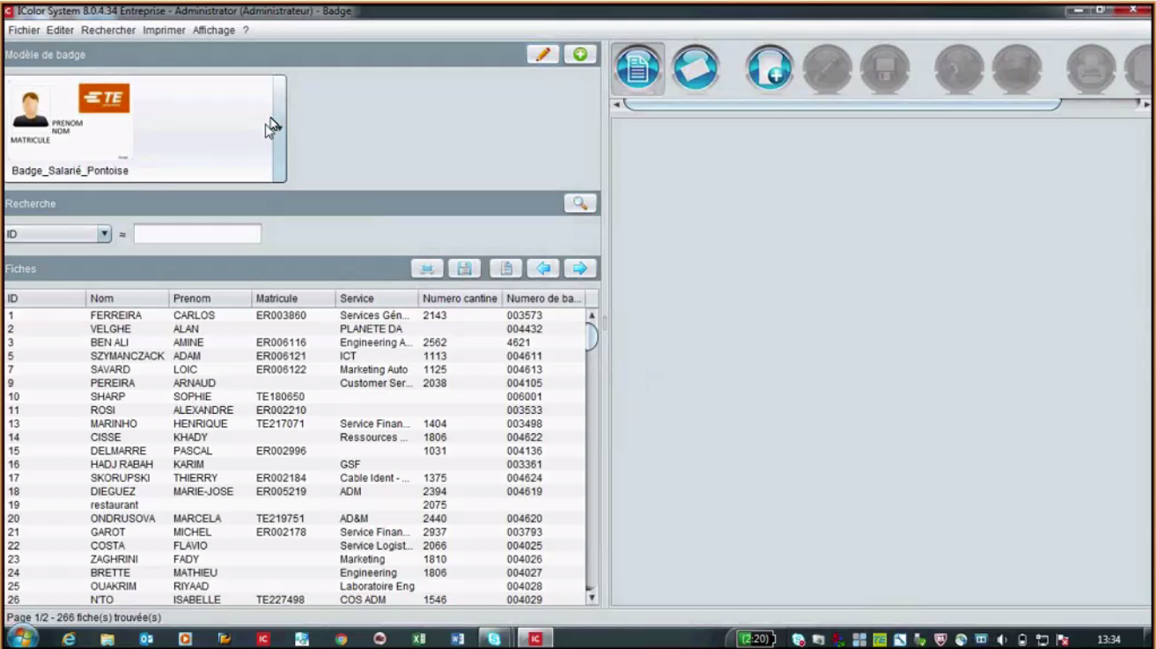
main application window
Persons from different locations and external persons are stored in different tables.

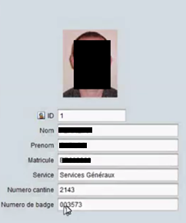
An example of user data stored in the SQL data base that is needed to create an id card.

TECHNOLOGY RELATED

Technical Overview
I-Color is a Windows desktop software that can connects to a Microsoft SQL Server database.

Application Architecture

I-Color is a Windows desktop software that can connects to a Microsoft SQL Server databsse.

Application Platform

Production, UAT and Development Locations
I-Color is a standard Vendor software. There is no development.

Interfaces to other systems
A manual data import of employee data is made regularly.

Documentation
Vendor documentation is available under: https://www.system-icolor.com/en/download.php
  - Third Party Tools
No other tools are needed for I-Color.

Technical Environment

Server Names
The Microsoft SQL Server database “ICOLOR” is located on the “fr509db01” server.
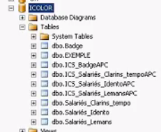
Table structure if I-Color

Web Locations
Vendor Website: https://www.system-icolor.com
Software download: https://www.system-icolor.com/en/download.php
Support Contact: https://www.system-icolor.com/en/contact.php

Software Requirements
A windows desktop PC is needed. The Card writer is connected using USB.

Server/Application access requirements
The two available application can be reached using remote desktop connection on Gratay, Philippe or Ferreira, Carlos machines.
The logon user name is: admin
The SQL server user name is: XXXXX

Test data and Test environment
Not available.

Forms / Reports
No applicable.

Datasets and Databases
The Microsoft SQL Server database “ICOLOR” is located on the “fr509db01” server.

OPERATIONAL REQUIREMENTS

Application installation
Two licenses are available for France.
For a new installation- of I-color, a temporary key is being used
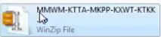
Temporary key

After the setup, the I-Color vendor support need to be called. The supporter will identify the customer and remotely hand out a working full version key that will be applied with the next start of the application that will connect to the vendor for a key check.

Application Administration
There are only two I-Color8 licenses for France available.
Actually two installations of I-Color exists on two separate employee machines:
- Gratay, Philippe (pgratay@te.com)
- Ferreira, Carlos (cferreira@te.com)
No Active Directory authentication is used. The Software ask for a user name and password when starting.

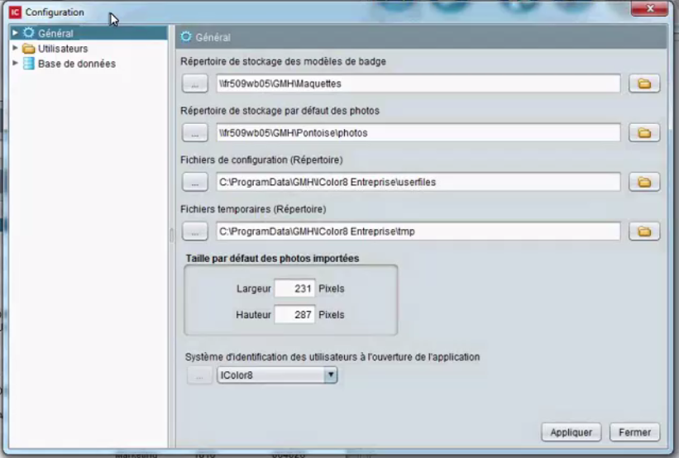
Configuration dialog is the part of the application, who witch the SME is responsible for.

Disaster Recovery Process & documentation
Not used.

Daily, Weekly, Monthly, Quarterly, Monthly Monitoring Checks/Activities
An employee data import to the I-Color Database is needed for keeping the employee data actual.

On Demand/Request
Sometimes the configuration data need to be changed or set after a new installation.

Backup Information
The SQL Database is being backed by the usual daily backup task. Maintained by the IT Service team.

PROCESS RELATED

Change Control
Not applicable.

Problem Management
Not applicable.

Release Management
Not applicable.

CONTACT INFORMATION

Business / Client Contacts
Internal clients only.

Support Team Contacts
IT Support France

Third Parties Contact Information
GMH IDENTIFICATION INFORMATIQUE
NII : FR52 434315347

Registered office:
60 route de Sartrouville - Parc Les Grillons - Bâtiment 1
78230 LE PECQ – France

Tel : +33 (0)1 39 76 55 10
Mail : website@group.gmhidentification.com
Web: https://www.system-icolor.com/en/features.php.

Hands On ACTIVITIES

Typical Problems and their resolution
Path configuration need to be changed.

Ticketing and Non Ticketing Activities

REFERENCE DOCUMENTS
Application user guides available on vendors website.

